**LOGINRPGLE**

FLOGINPAGE CF E WORKSTN

DDSG S 15 INZ

DIND S 1 0 INZ

DCMD S 200 INZ

DLEN S 15 5

*

DCMDEXEC PR EXTPGM('QCMDEXC')

DCMD 200

DLEN 15 5

DUSDTAARA UDS DTAARA

DNAME 10

C DOW *IN03='0'

C EXFMT LOGINSCRN

C EVAL MSG = *BLANKS

C IF *IN03 = '1'

C LEAVE

C ENDIF

c EXSR LOADLOGIN

C ENDDO

C EVAL *INLR = '1'

*-----------------------------------------------------------

C LOADLOGIN BEGSR

IND = 0;

DSG = ' ';

EXEC SQL

SELECT 1 INTO :IND FROM USERFILE WHERE

USERID = :USER AND PASSWORD = :PSWD ;

IF IND = 1;

*IN87 = '0';

C *LOCK IN USDTAARA

C EVAL %SUBST(USDTAARA:1:10) = USER

C OUT USDTAARA

EXEC SQL

SELECT DESIG INTO :DSG FROM USERFILE WHERE

USERID = :USER AND PASSWORD = :PSWD ;

IF DSG = 'EMPLOYEE';

CMD = 'GO EMPMENU';

LEN = %LEN(%TRIM(CMD)) ;

CMDEXEC(CMD:LEN) ;

ELSEIF DSG = 'MANAGER';

CMD = 'GO MGRMENU';

LEN = %LEN(%TRIM(CMD)) ;

CMDEXEC(CMD:LEN) ;

ELSEIF DSG = 'ADMIN';

CMD = 'GO ADMENU';

LEN = %LEN(%TRIM(CMD)) ;

CMDEXEC(CMD:LEN) ;

ENDIF;

ELSE;

MSG = 'WRONG CREDENTIALS' ;

*IN87 = '1';

ENDIF;

C ENDSR

This program is designed to handle the login process for a workstation. It continuously displays a login screen until the user either logs in successfully or exits the program. When the user enters their credentials, the program checks the USERFILE database to validate them. If the credentials are correct, it determines the user's designation and navigates them to the appropriate menu (Employee, Manager, or Admin) based on their role. If the credentials are invalid, the program displays an error message. The program also updates a data area with the user's information upon successful login and ensures appropriate menu navigation through command execution. The main loop continues until the user decides to exit, at which point the program terminates.

STOCKENTRY

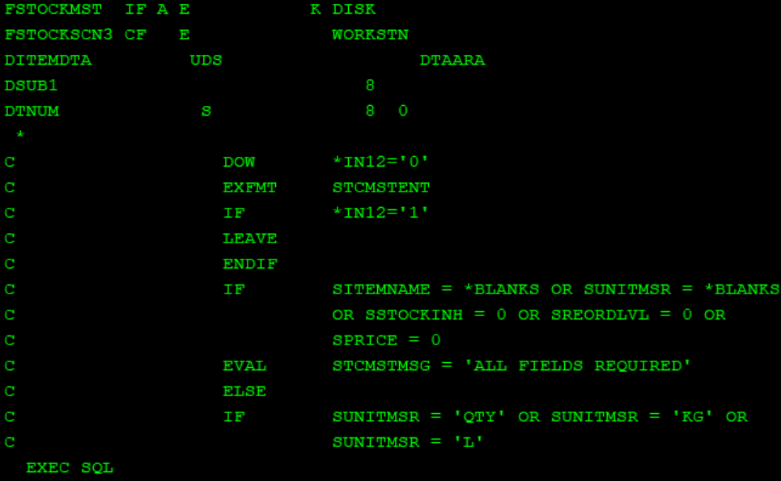

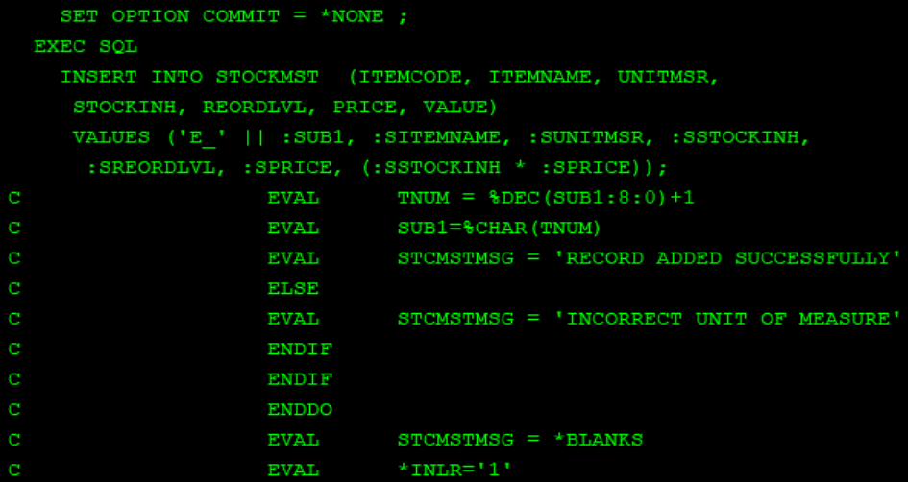

This program handles the entry and validation of stock item details. It continuously displays an input screen for stock master entry until the user exits. The program checks that all fields are filled in and that the unit of measure is valid (either 'QTY', 'KG', or 'L'). If the inputs are valid, it inserts the new stock item into the `STOCKMST` database table, generates a new item code by incrementing a counter, and displays a success message. If the inputs are invalid or the unit of measure is incorrect, it displays an appropriate error message. The program terminates when the user decides to exit.

GRCVDENTRY

This program manages the entry and validation of goods received information. It displays an input screen for goods received entry until the user exits. The program checks that all necessary fields are filled and verifies the item code. If the item code is valid, it records the user's information, date, and time. It retrieves the item price from the `STOCKMST` database, calculates the total value, and inserts the received goods details into the `GOODSRCVD` database. It also updates the stock quantity and value in the `STOCKMST` database. If any fields are missing or the item code is invalid, it displays an appropriate error message. The program terminates when the user decides to exit.

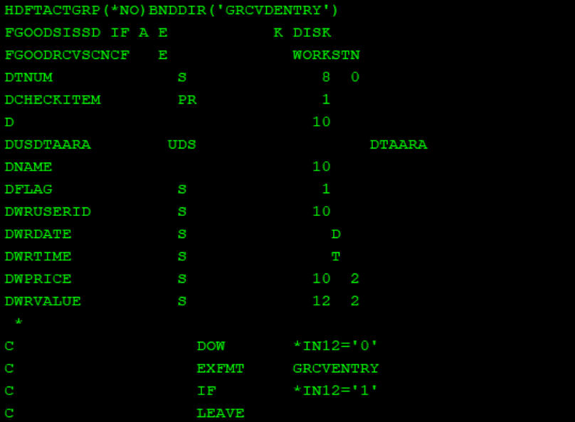

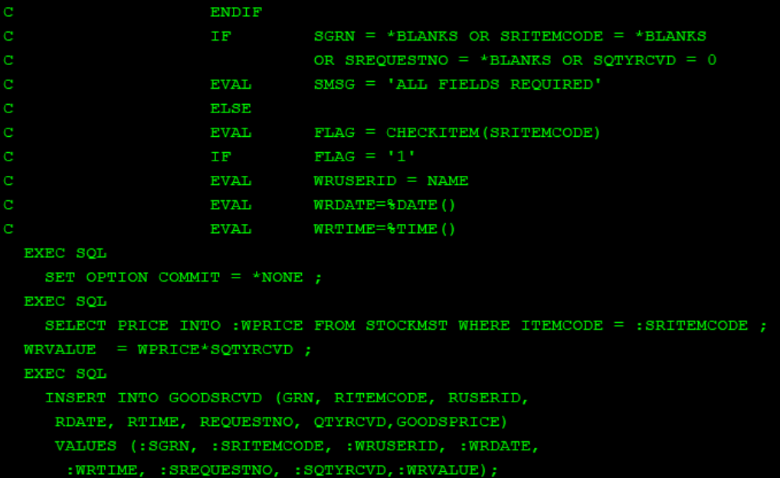

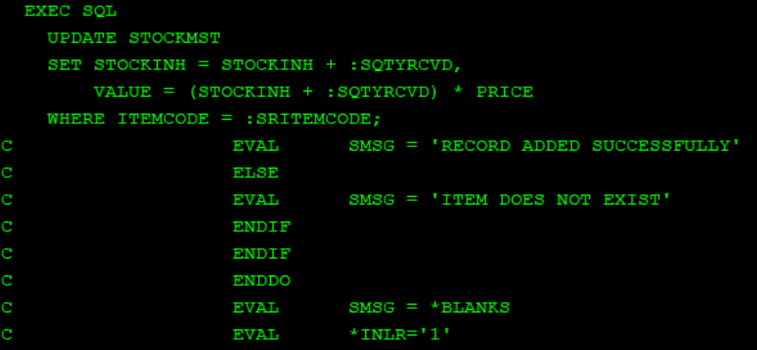

MOD_CHECK

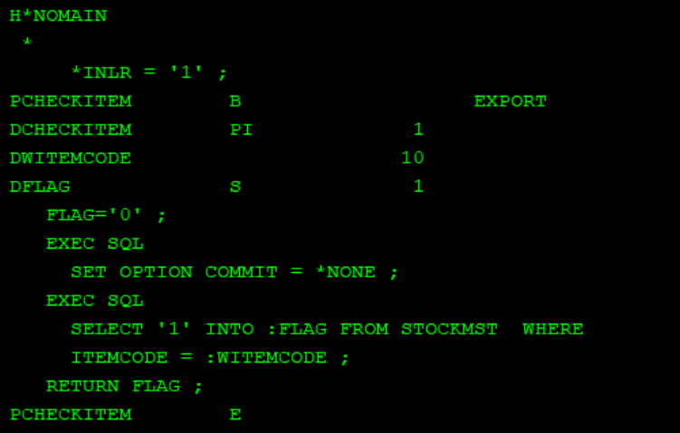

GISSENTRY

This program manages the issuance of goods. It displays an input screen for goods issuance until the user exits. It verifies that all necessary fields are filled and checks the item code's validity. If the item code is valid, it retrieves the available stock from the `STOCKMST` database. If the requested quantity exceeds the available stock, it displays an error message. If the stock is sufficient, it inserts the goods issuance record, updates the stock in the `STOCKMST` database, and displays a success message. If the item code is invalid or a duplicate record is detected, it displays an appropriate error message. The program increments a counter for each new issuance and terminates when the user decides to exit.

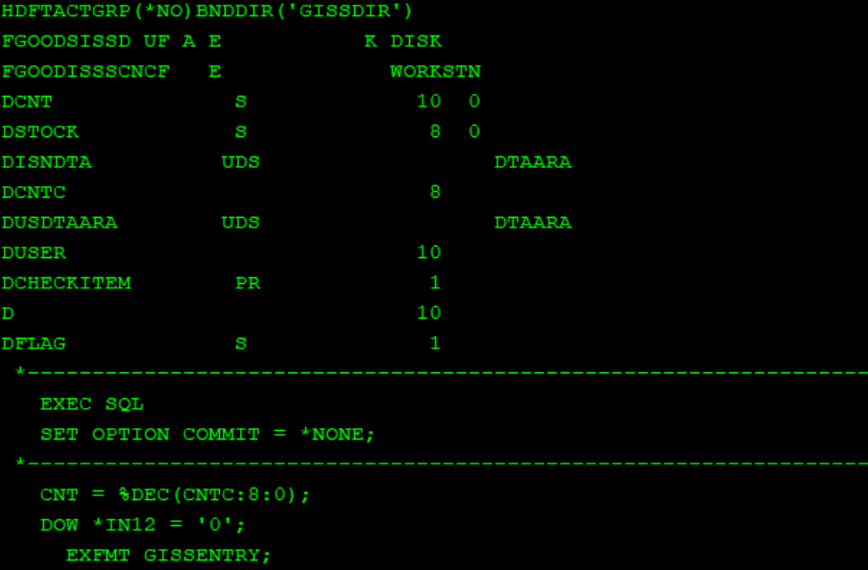

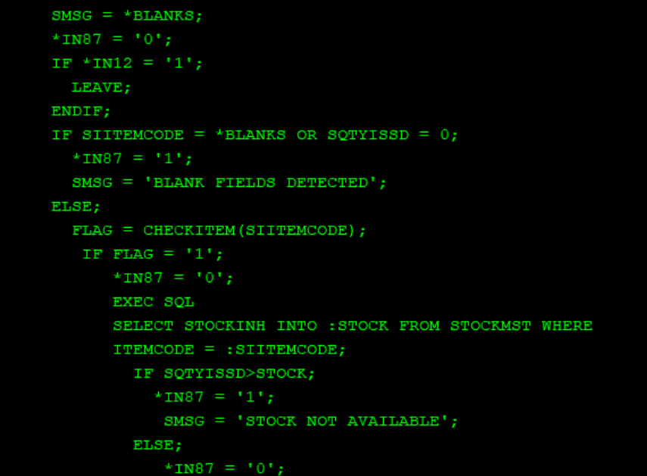

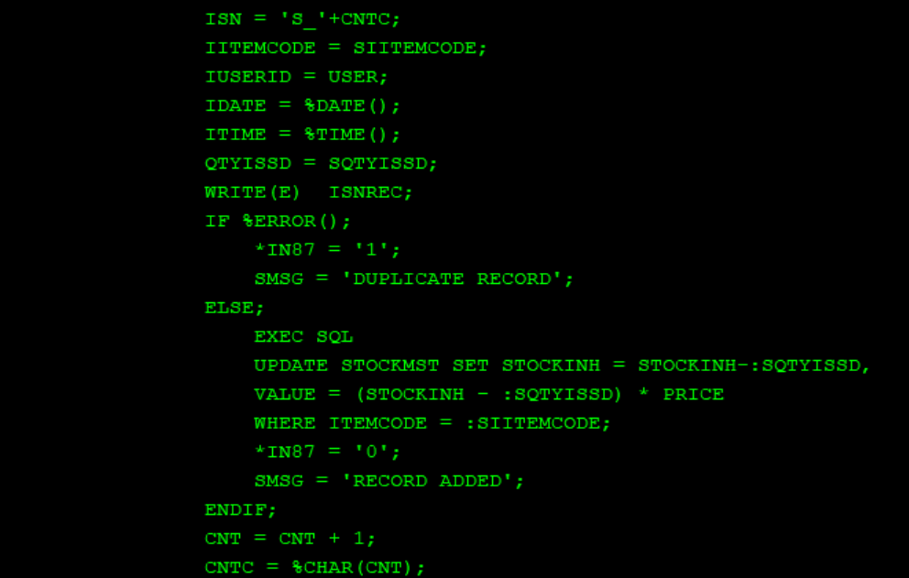

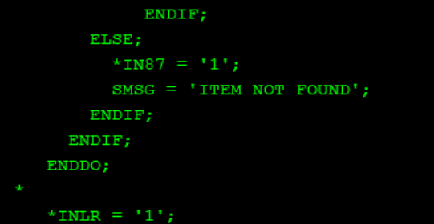

USERENTRY

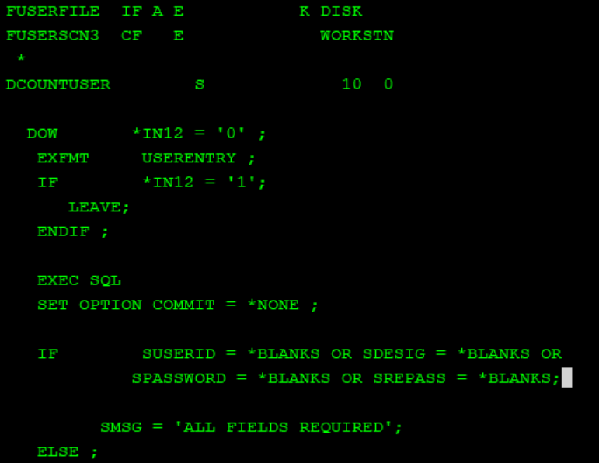

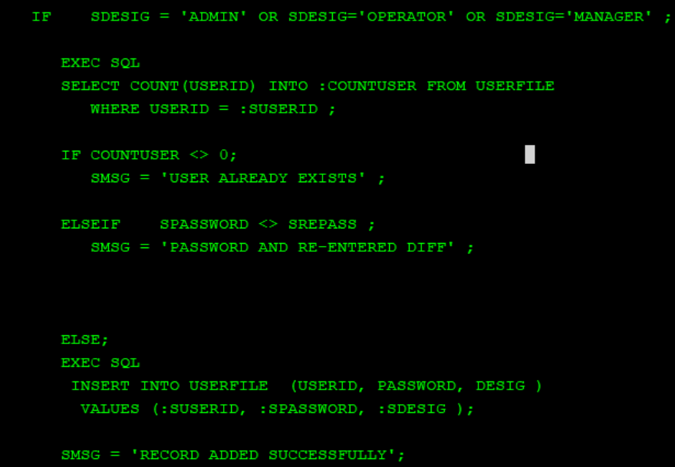

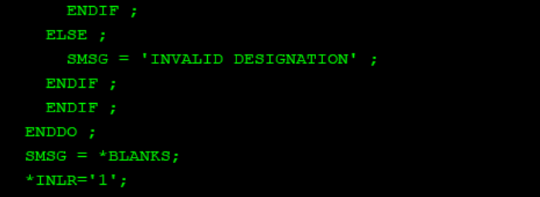

This program handles user entry and validation. It displays an input screen for user entry until the user exits. The program verifies that all fields are filled and checks if the user designation is either 'ADMIN', 'OPERATOR', or 'MANAGER'. If the fields are valid and the designation is correct, it checks if the user already exists in the `USERFILE` database. If the user exists, it displays an error message; if the password and re-entered password do not match, it displays a different error message. If the user does not exist and the passwords match, it inserts the new user details into the `USERFILE` database and displays a success message. If the designation is invalid, it displays an appropriate error message. The program terminates when the user decides to exit.

WANDTENTRY

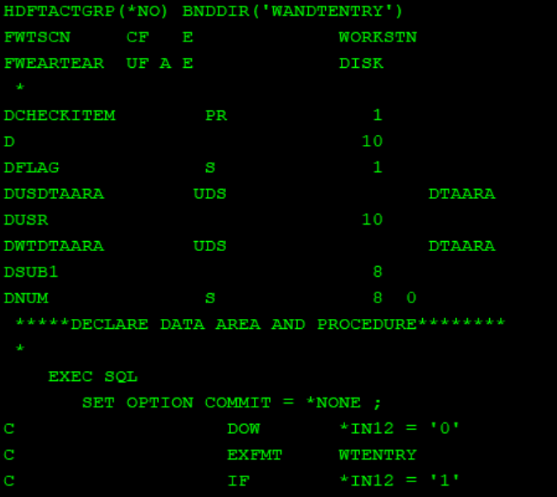

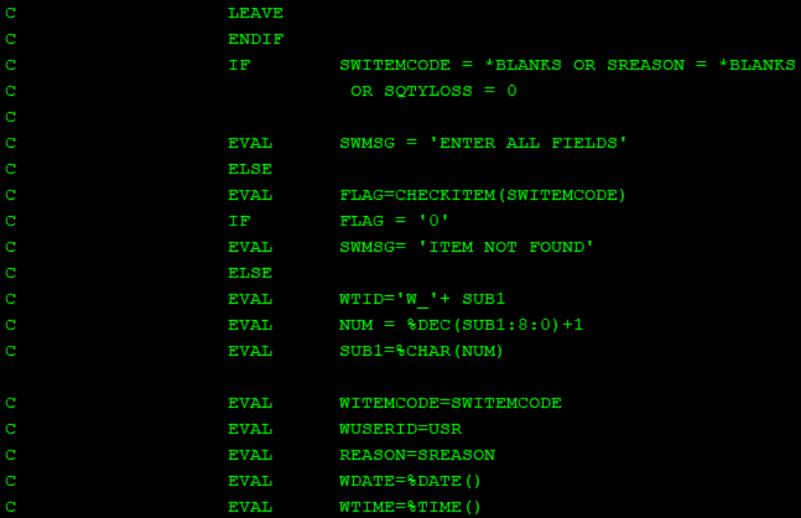

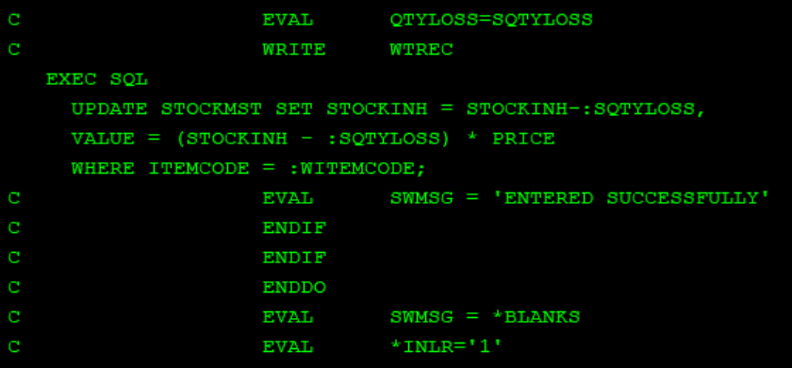

STOCKDSPLY

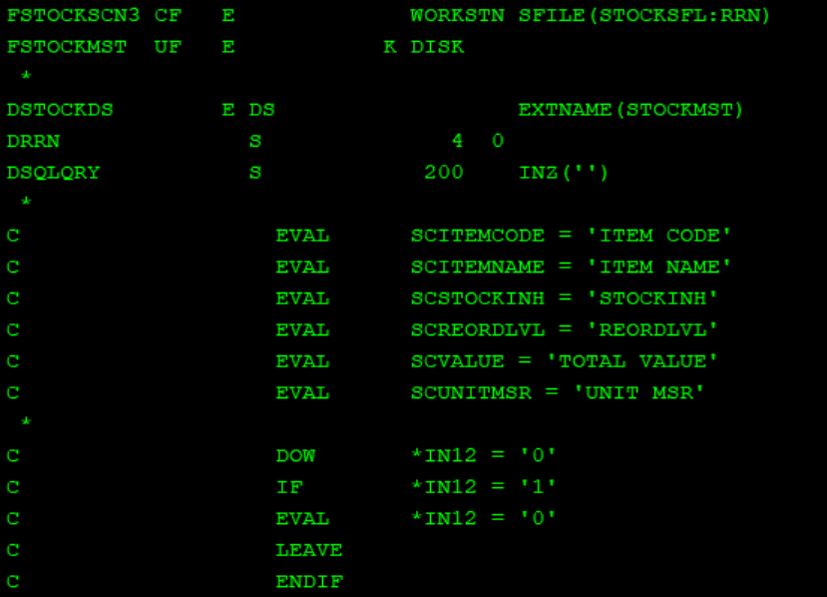

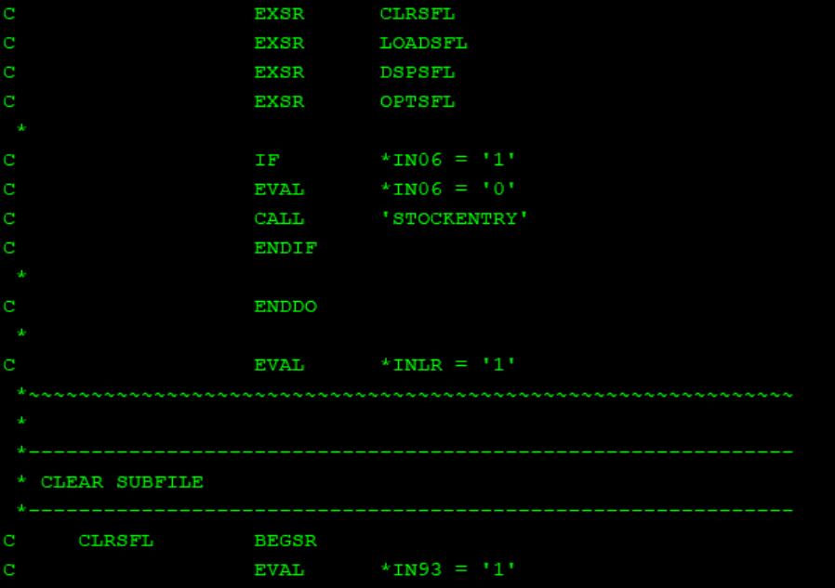

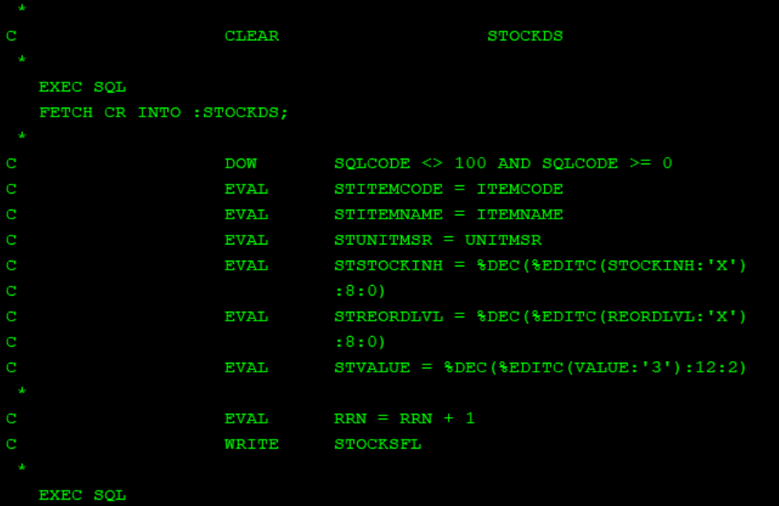

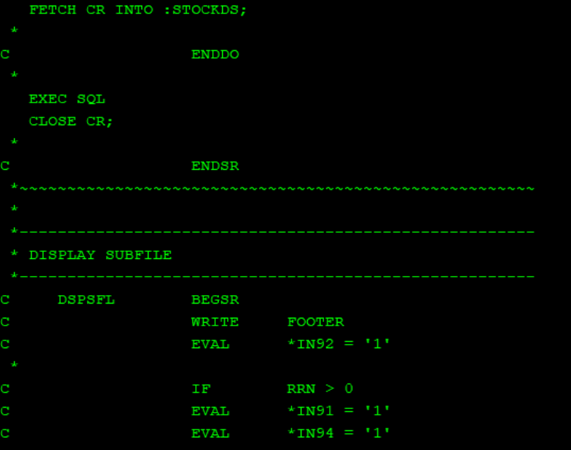

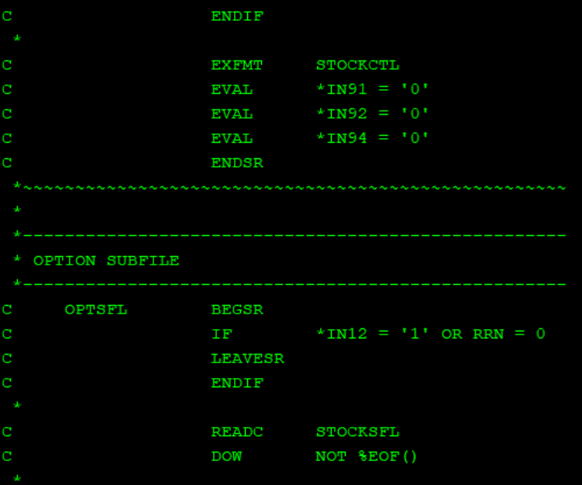

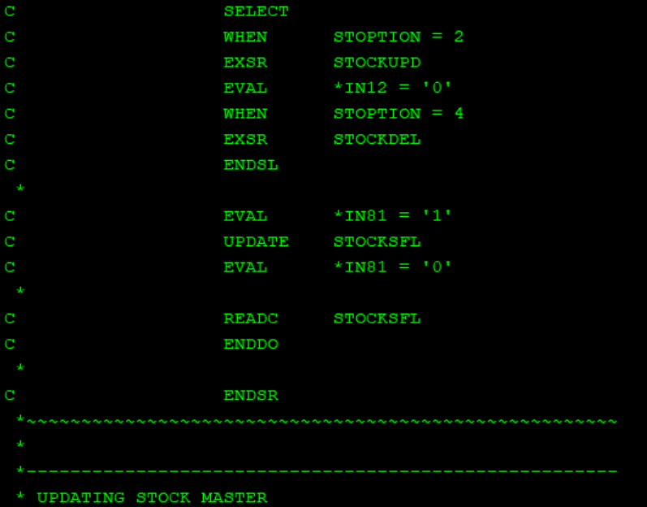

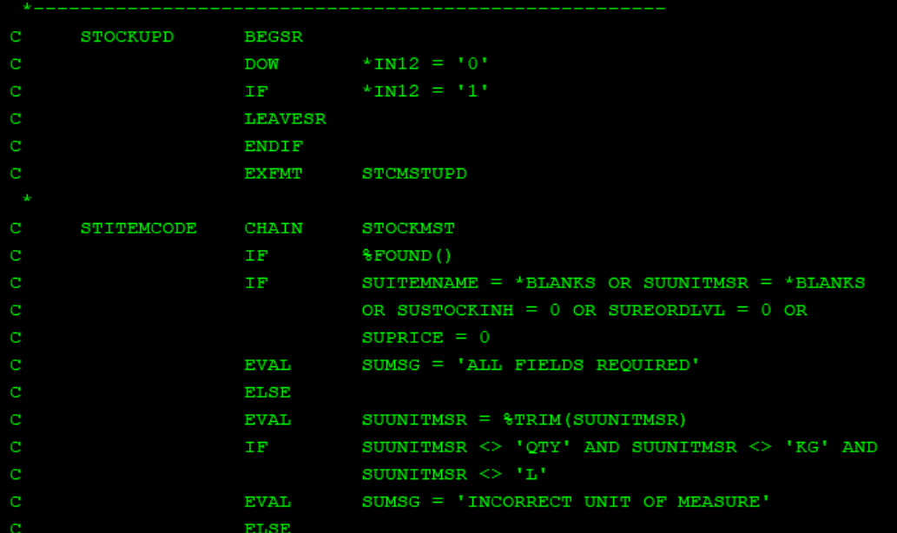

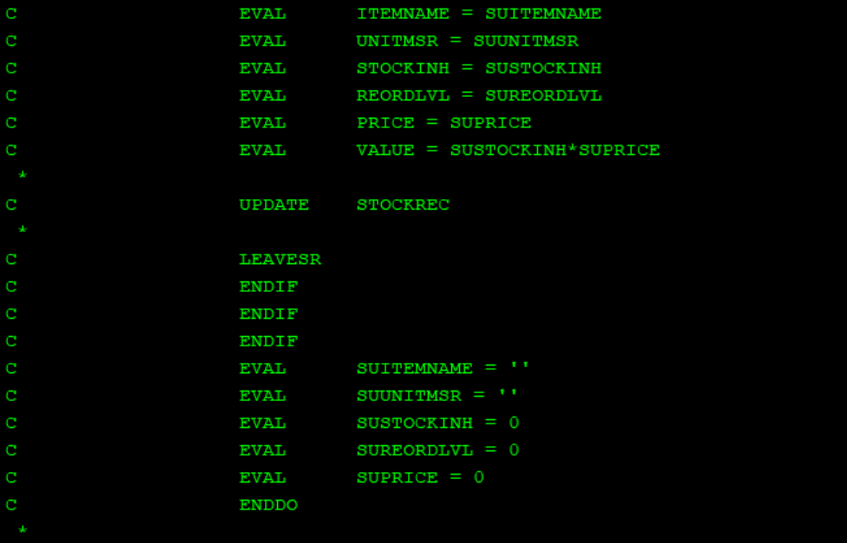

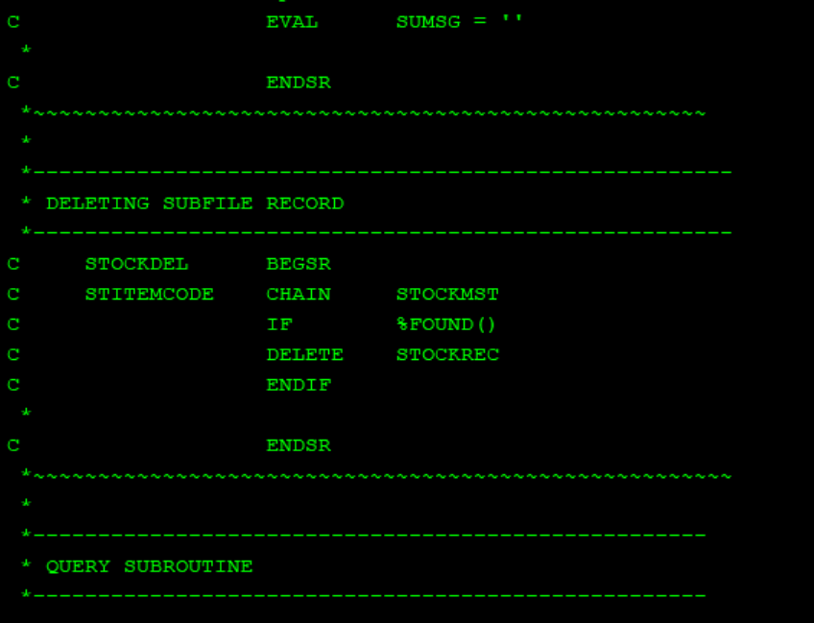

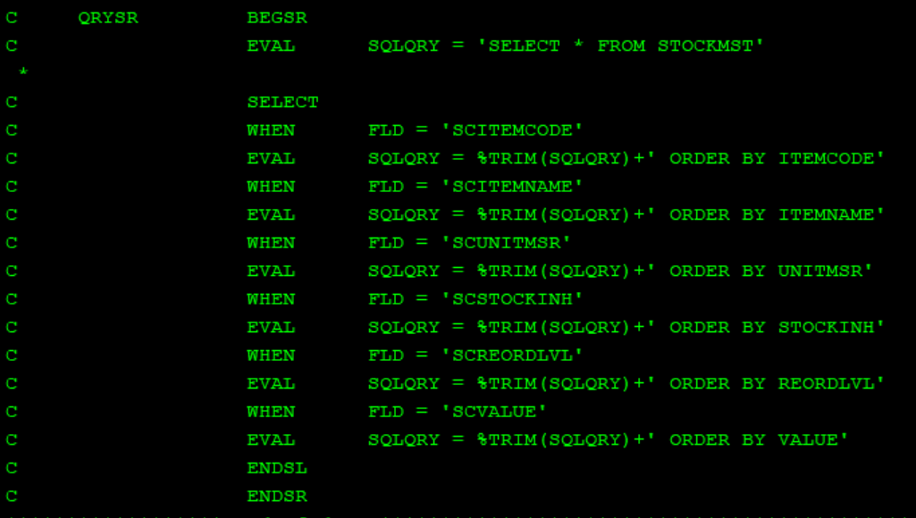

GRCVDDISPL

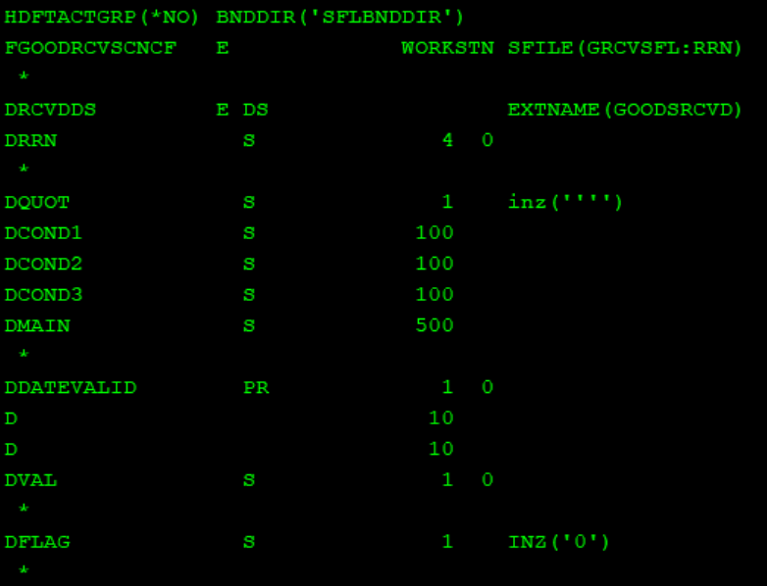

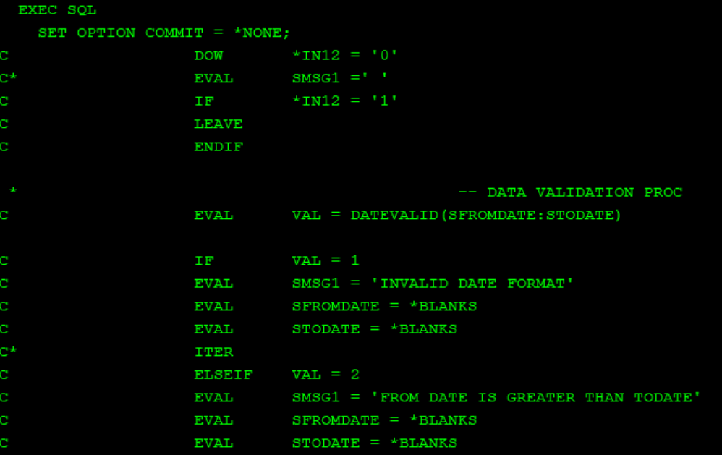

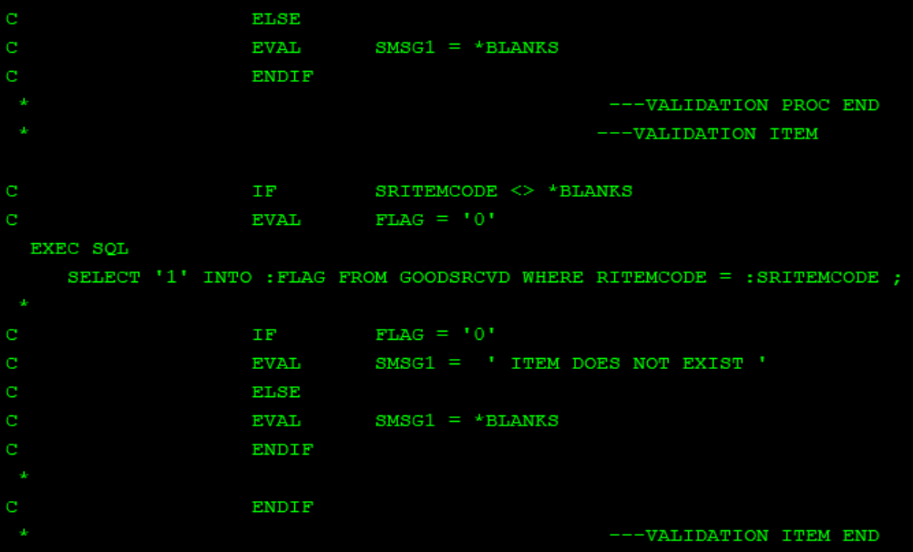

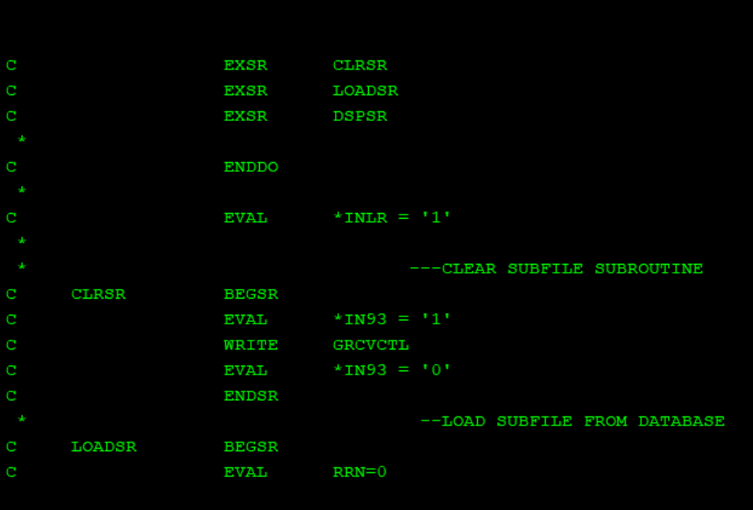

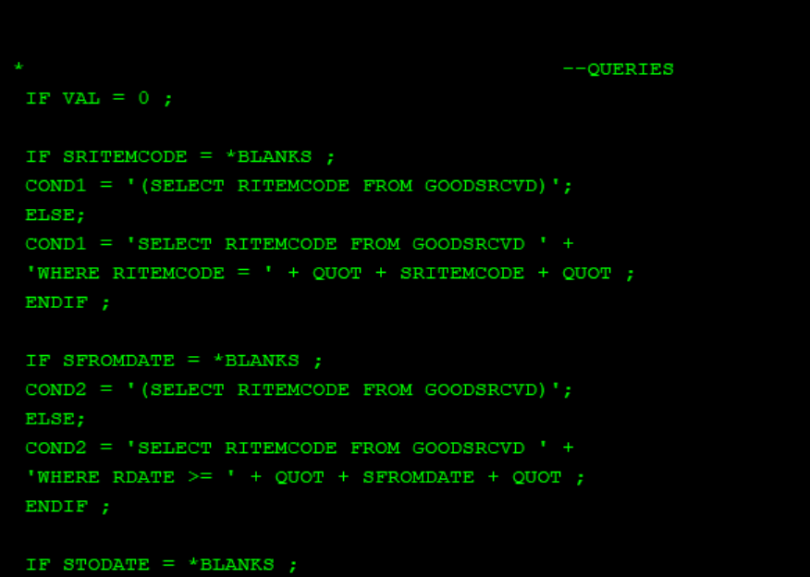

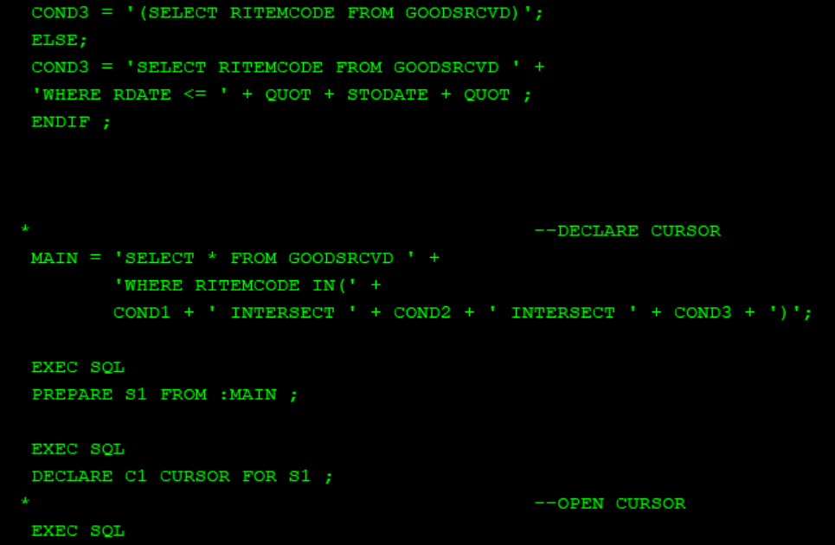

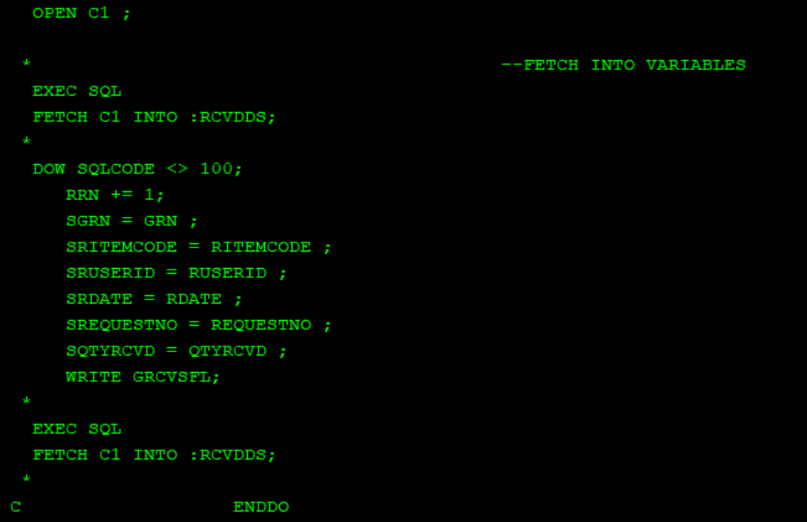

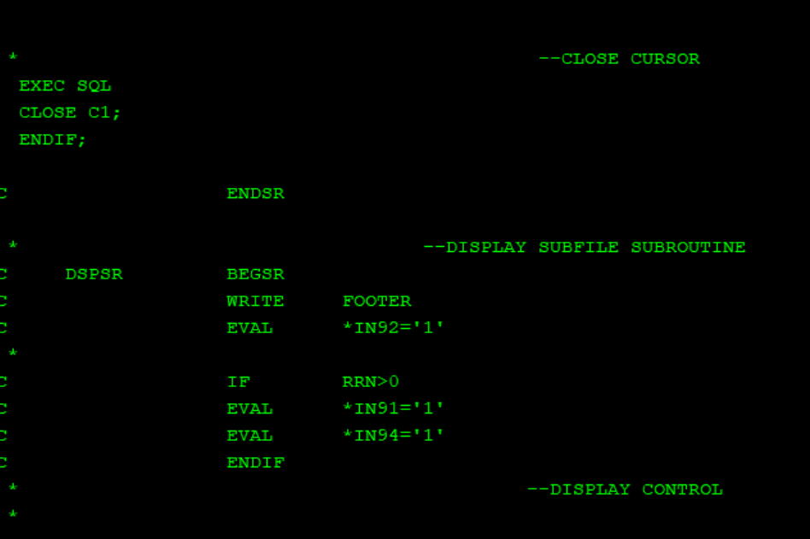

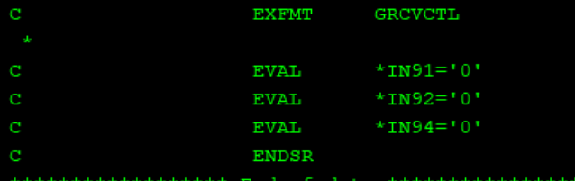

MOD_DATE

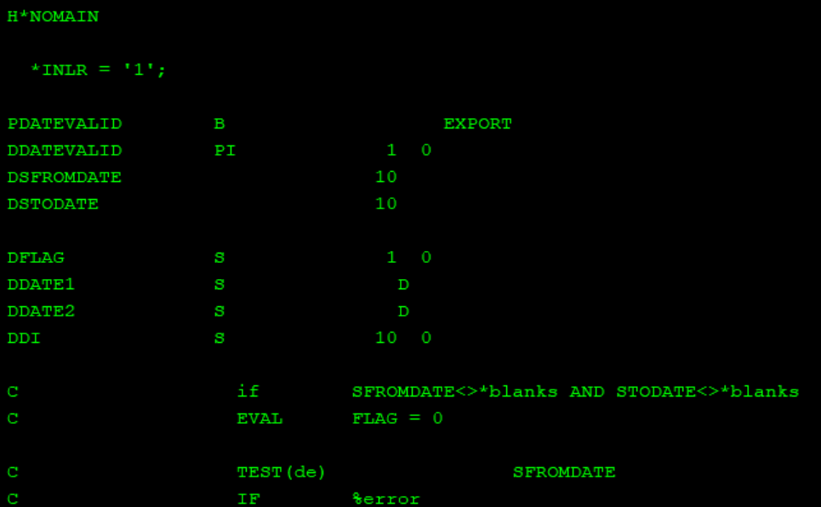

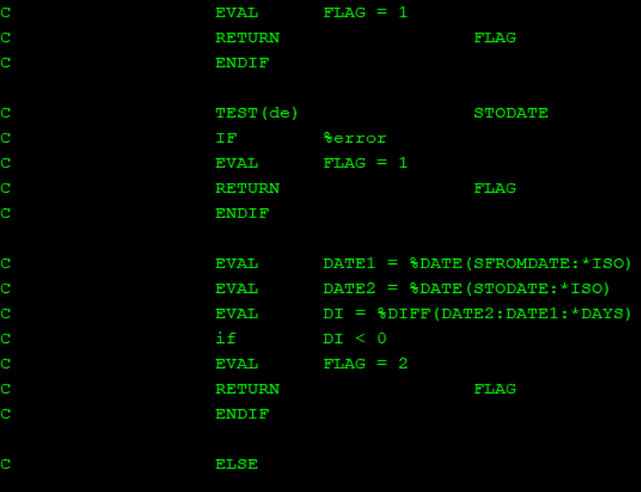

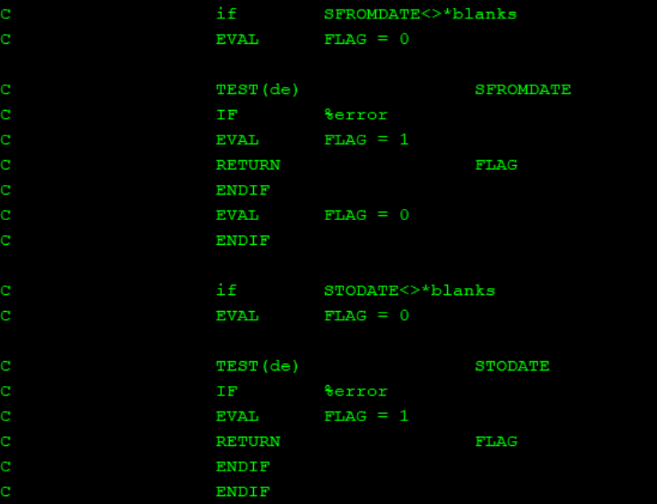

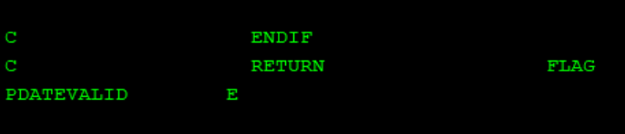

GISSSFL3

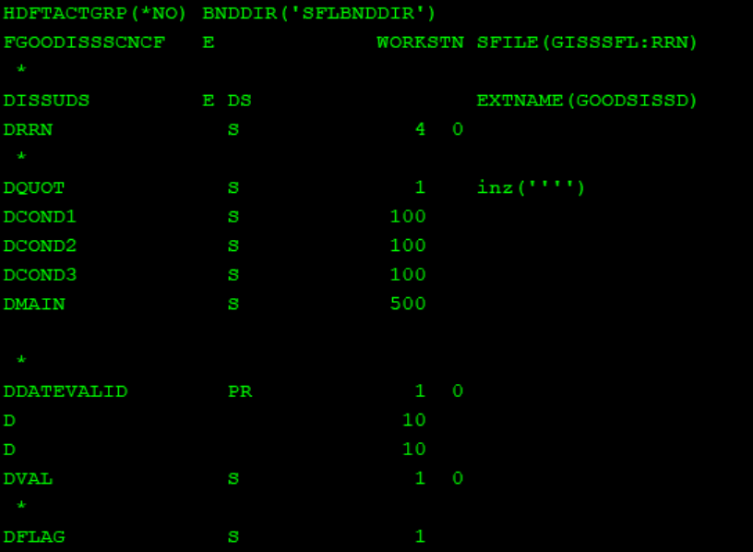

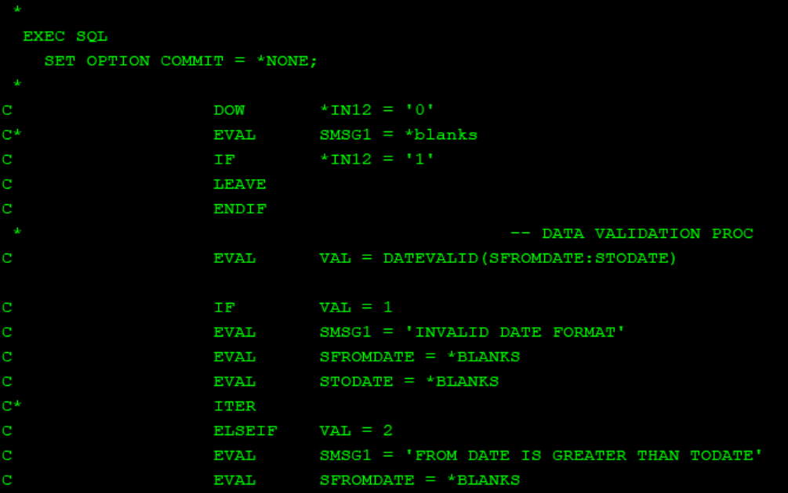

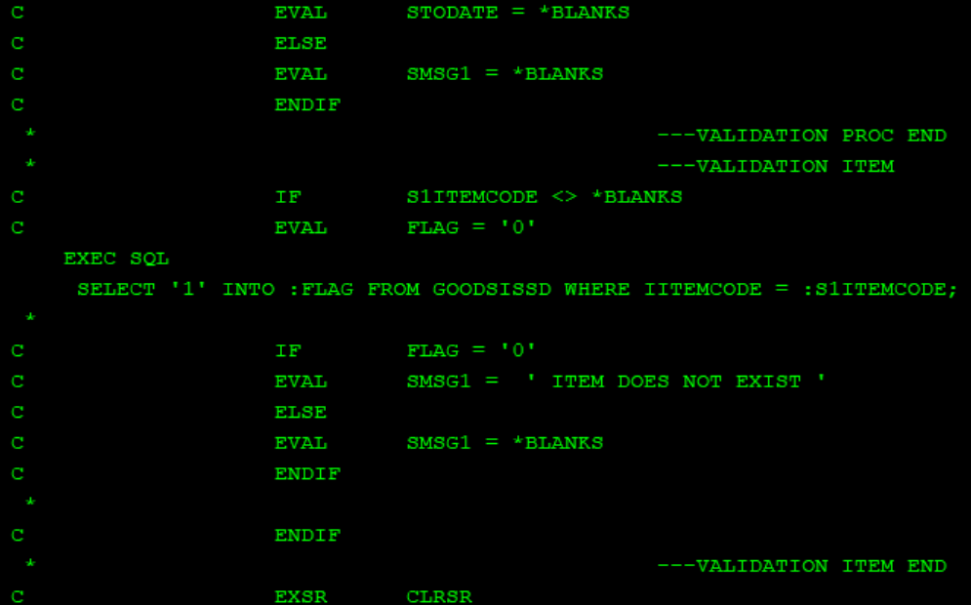

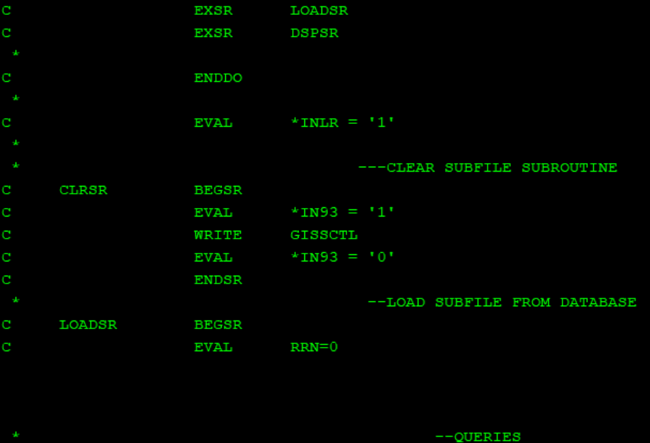

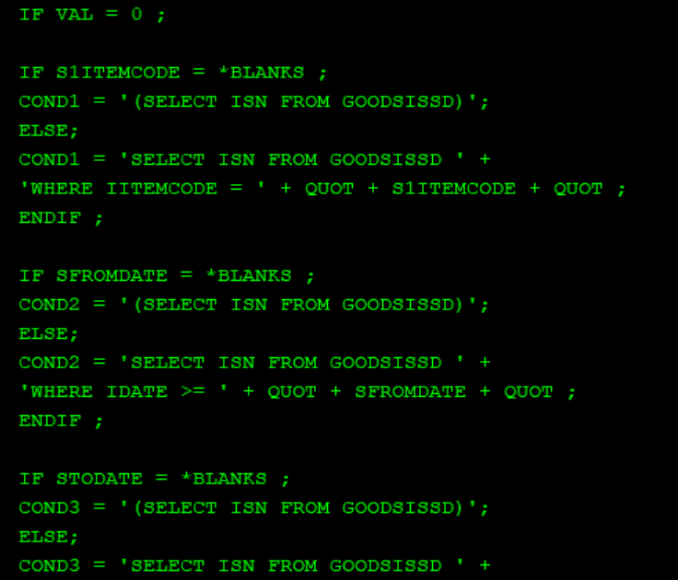

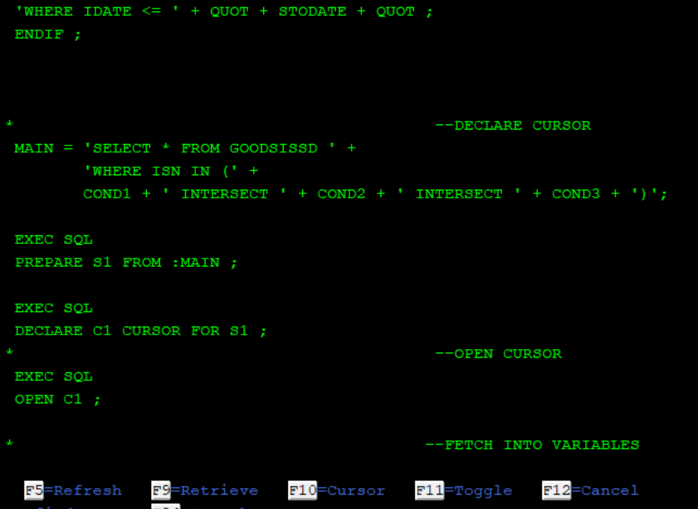

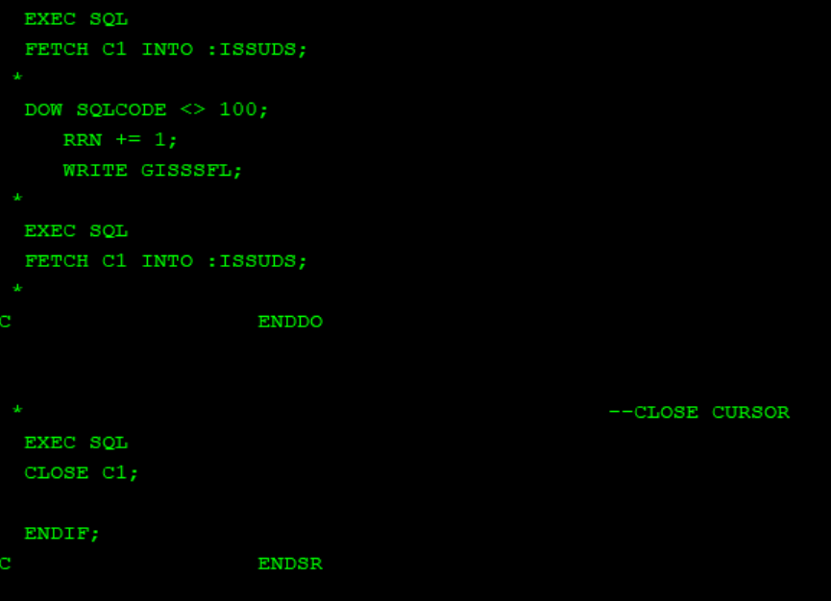

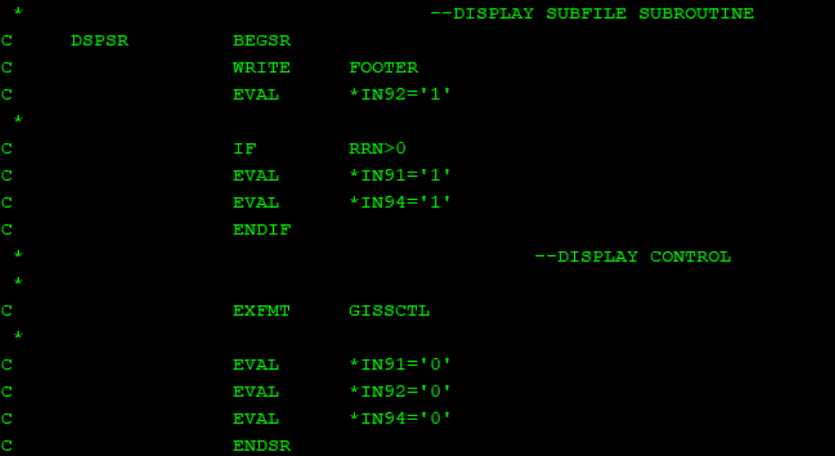

WTSFL

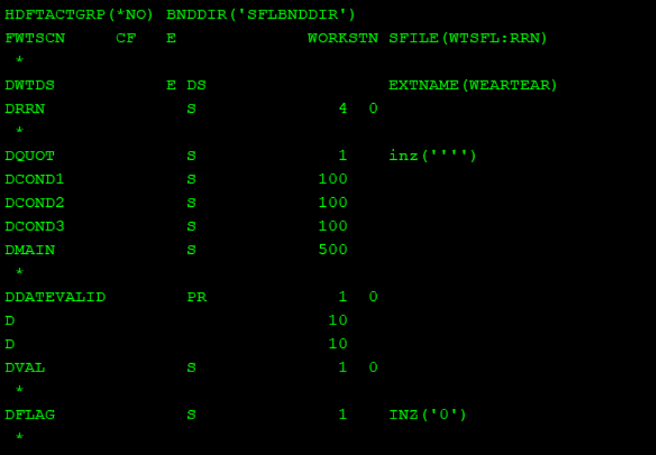

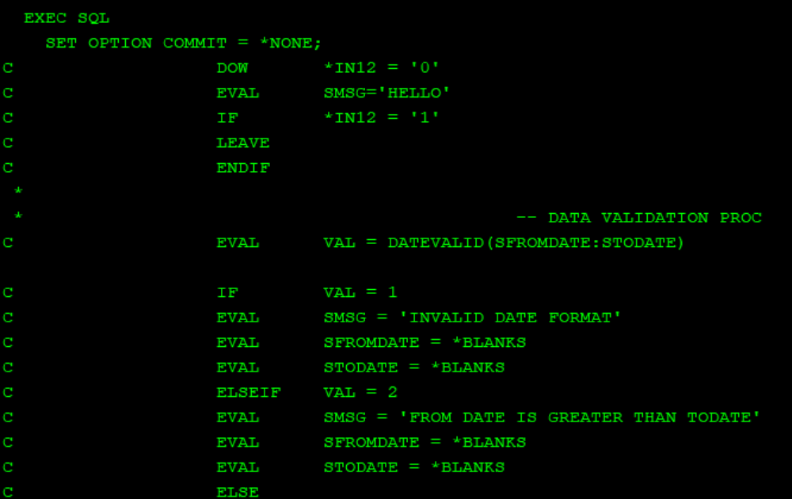

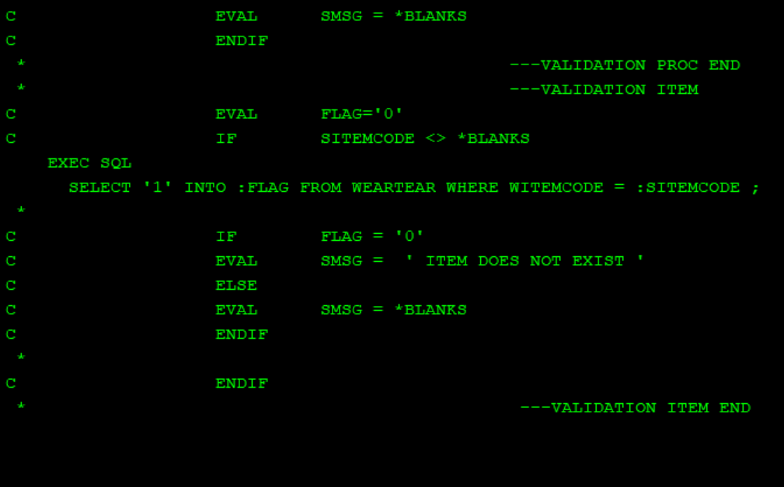

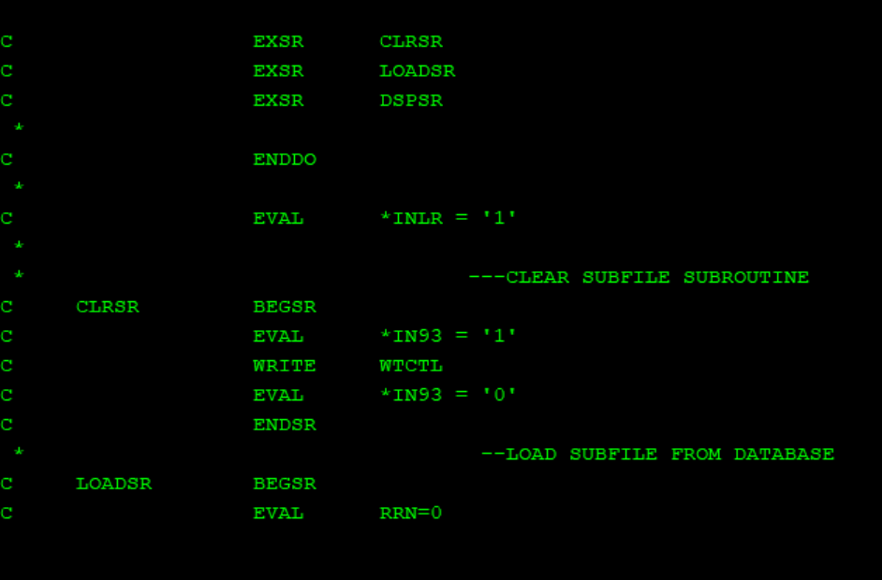

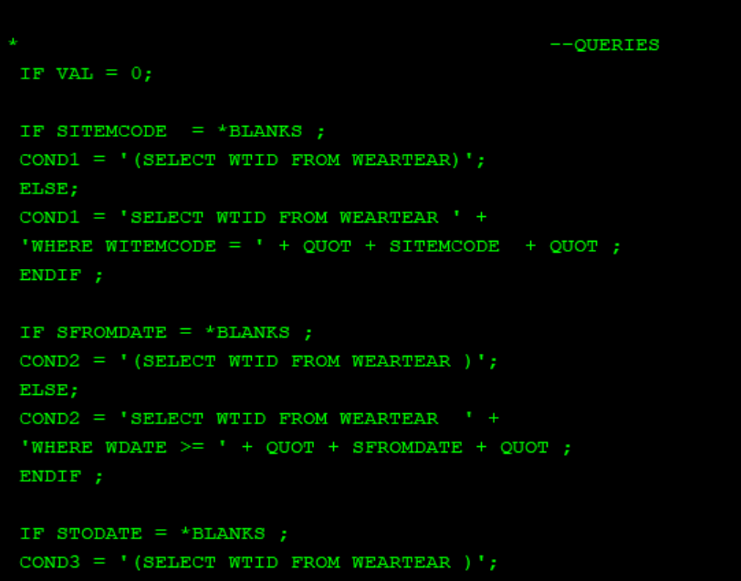

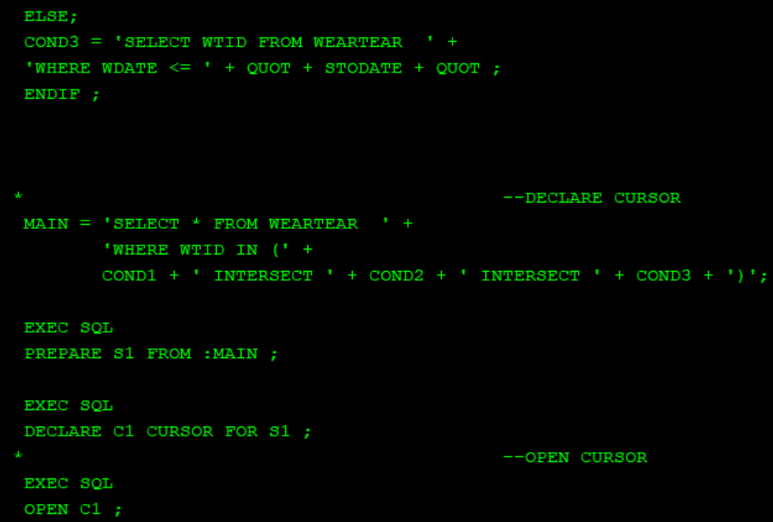

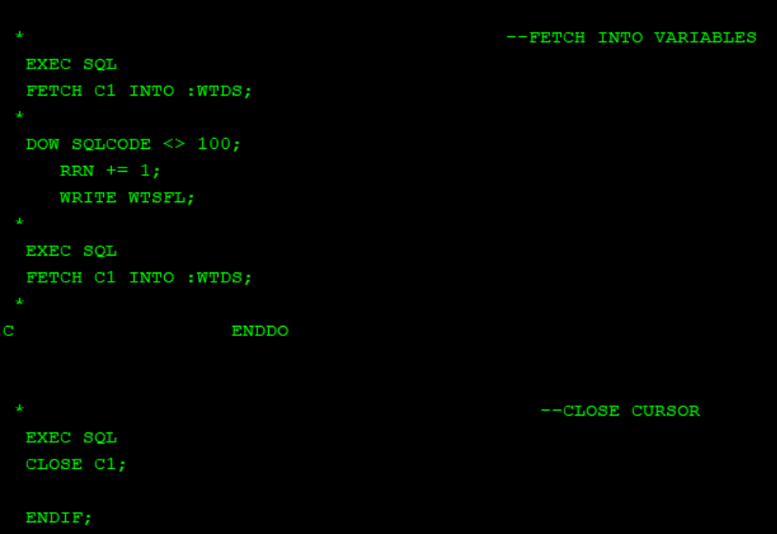

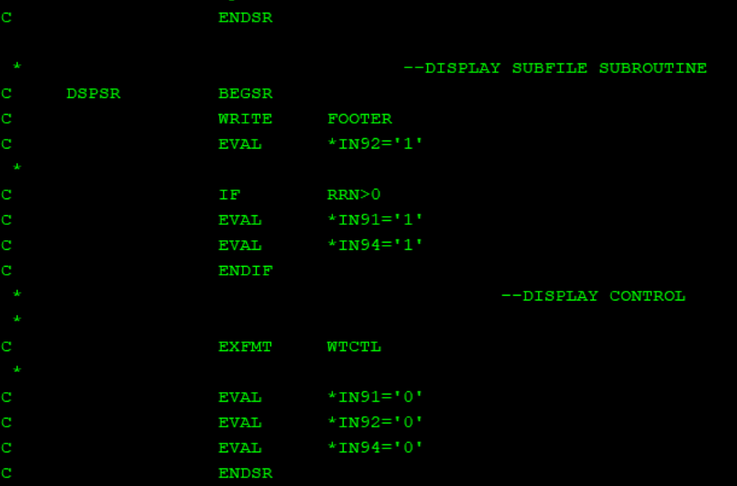

BLWLVLRPG

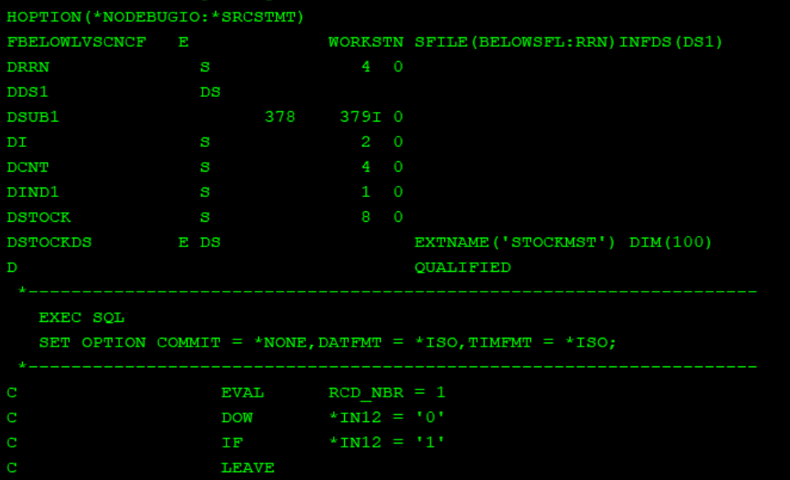

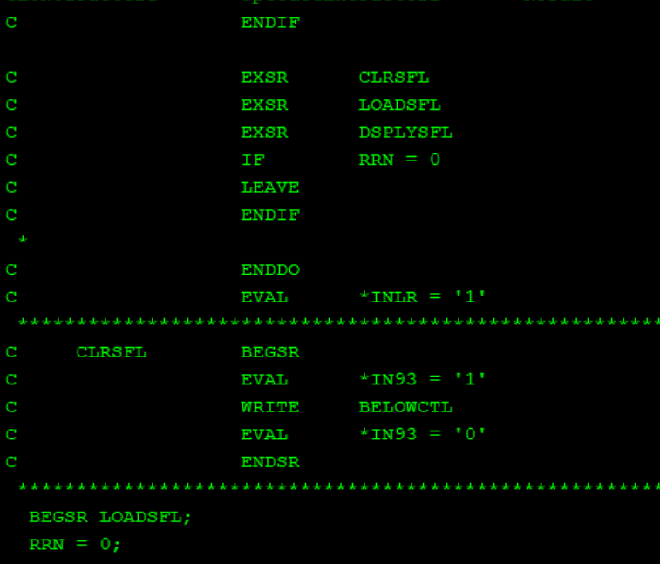

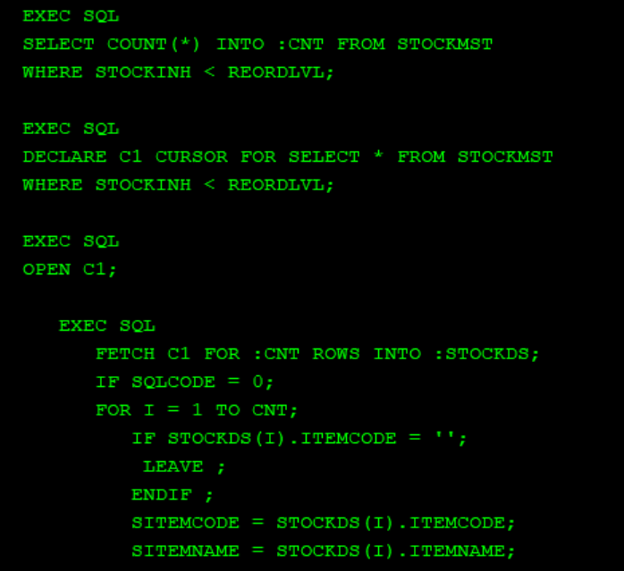

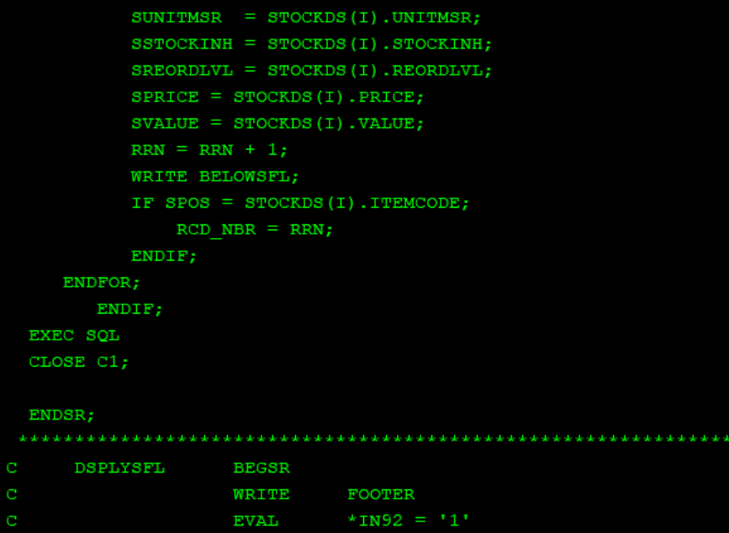

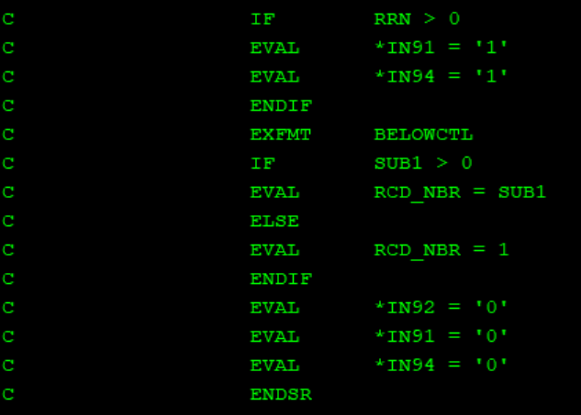

CLFMCGRPT

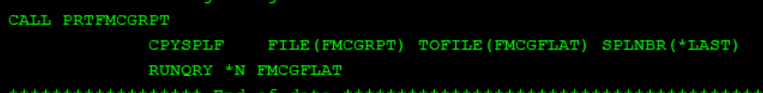

PRTFMCGRPT

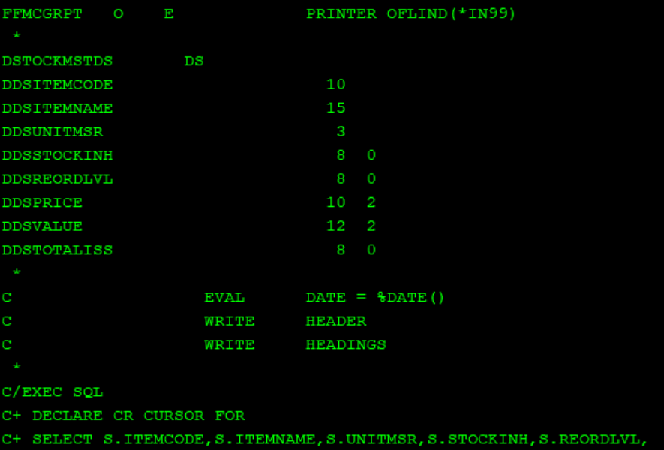

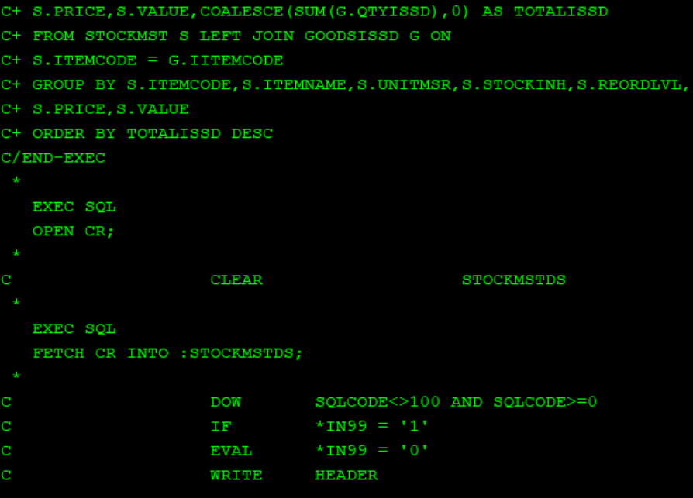

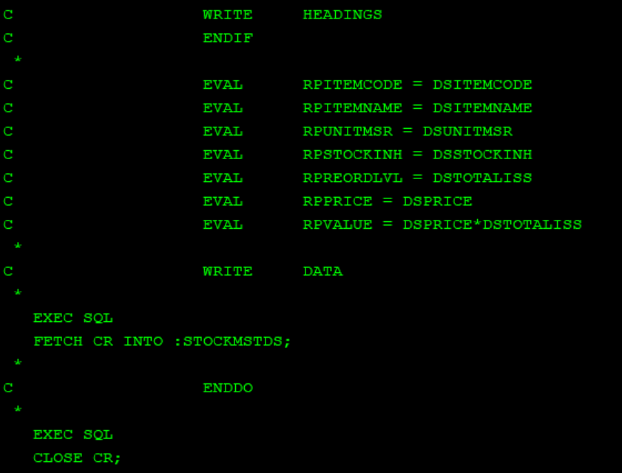

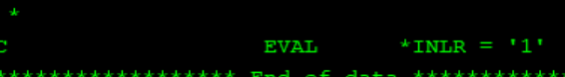

CLGISSDRPT

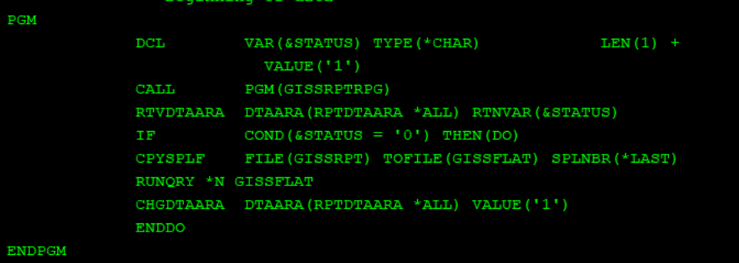

GISSRPTRPG

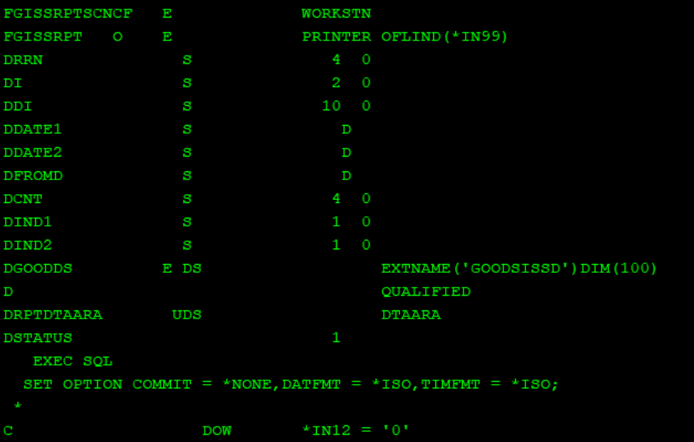

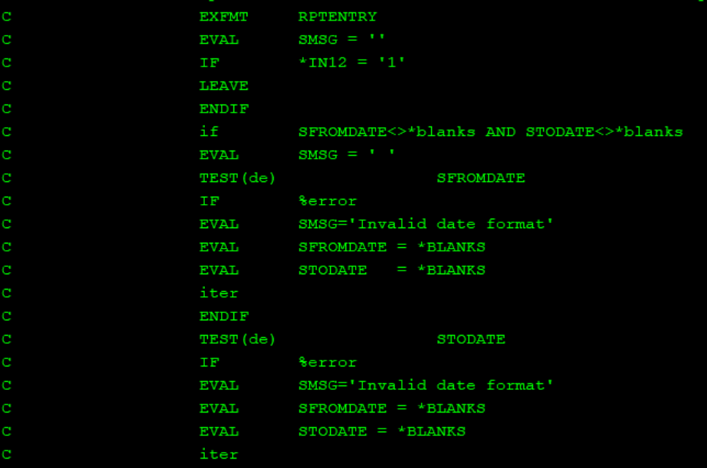

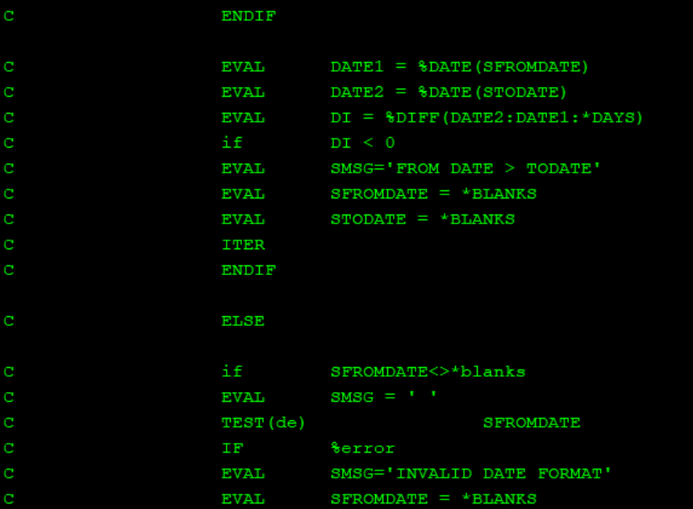

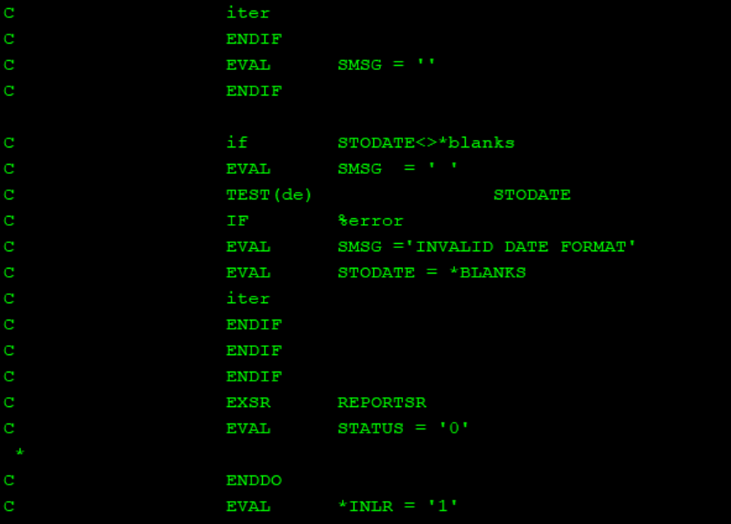

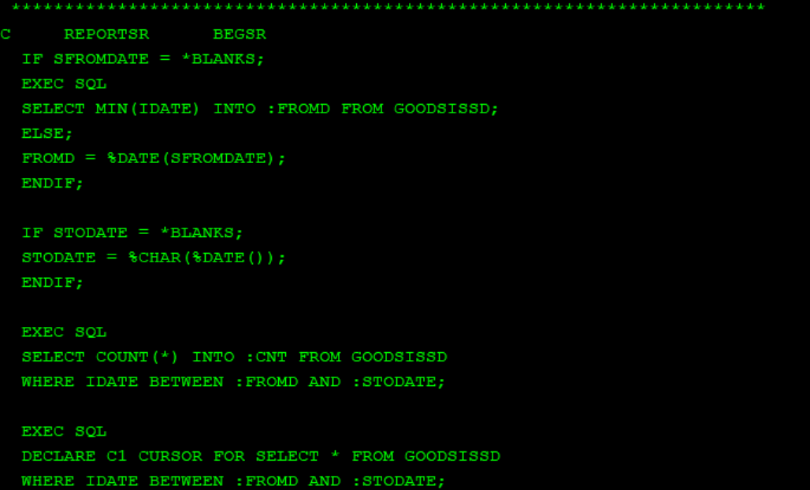

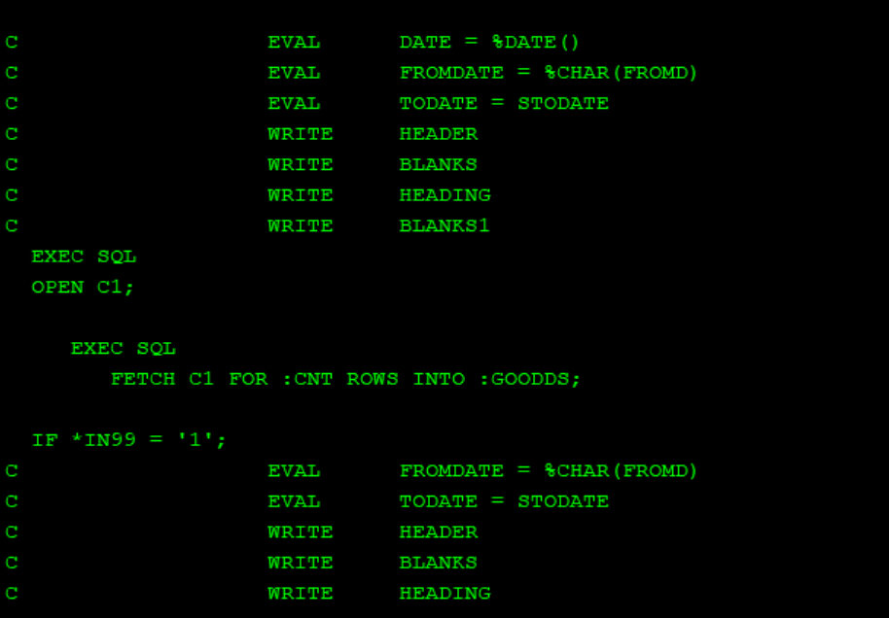

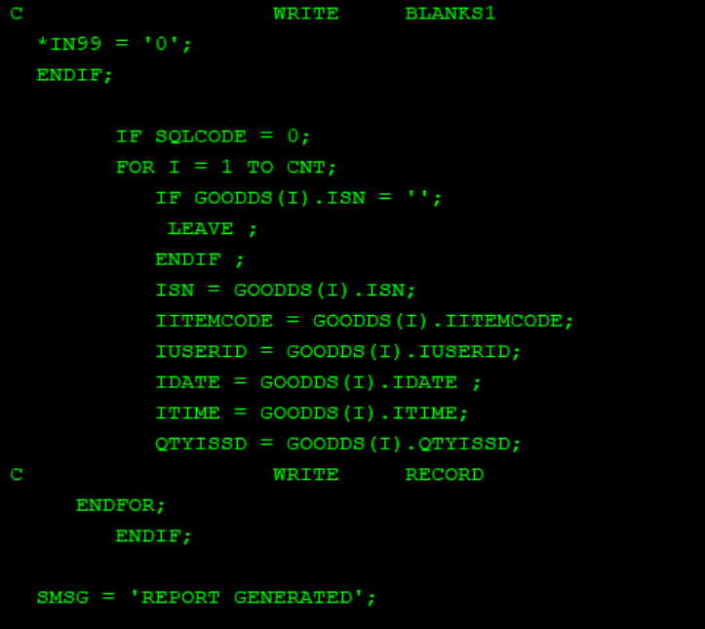

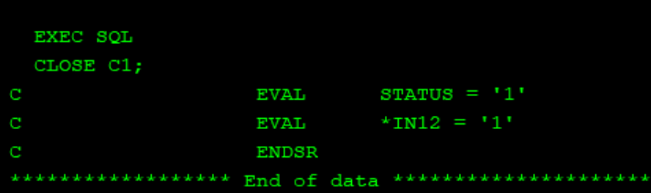

CLGRCVDRPT

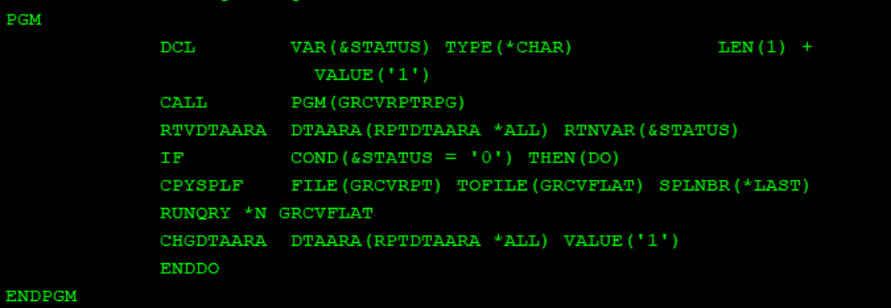

GRCVRPTRPG

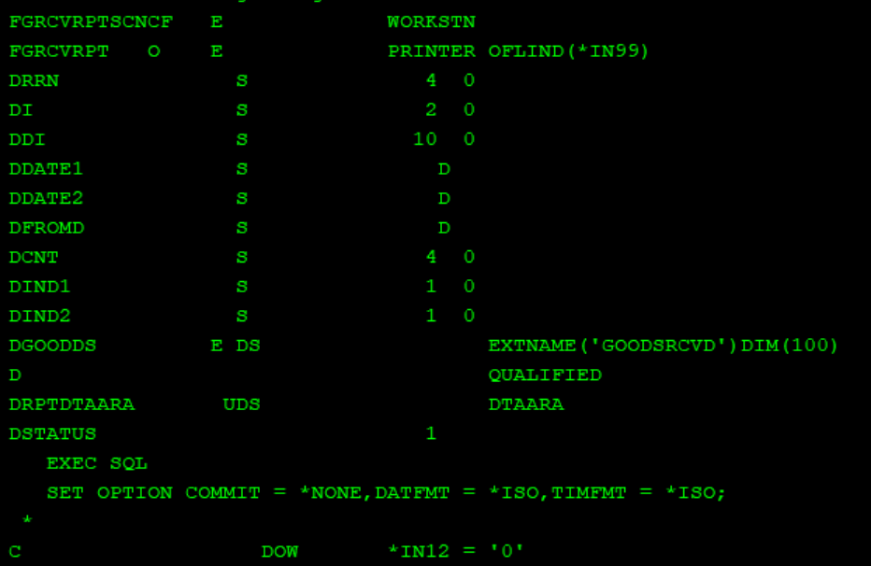

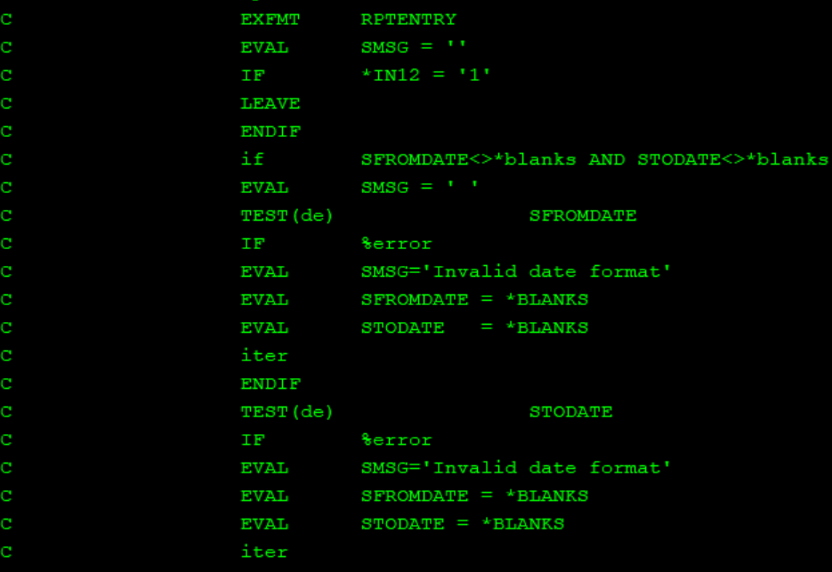

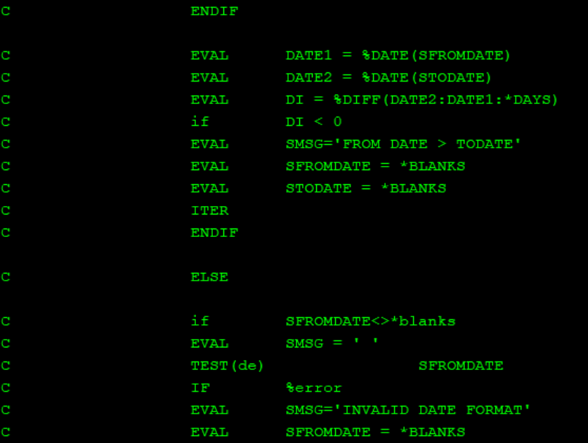

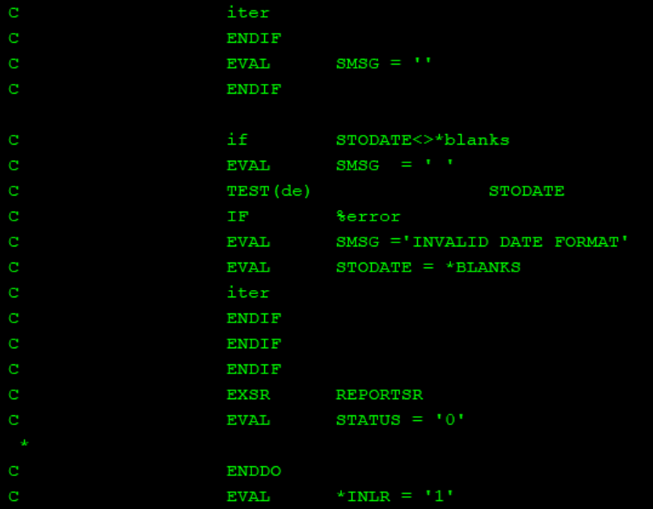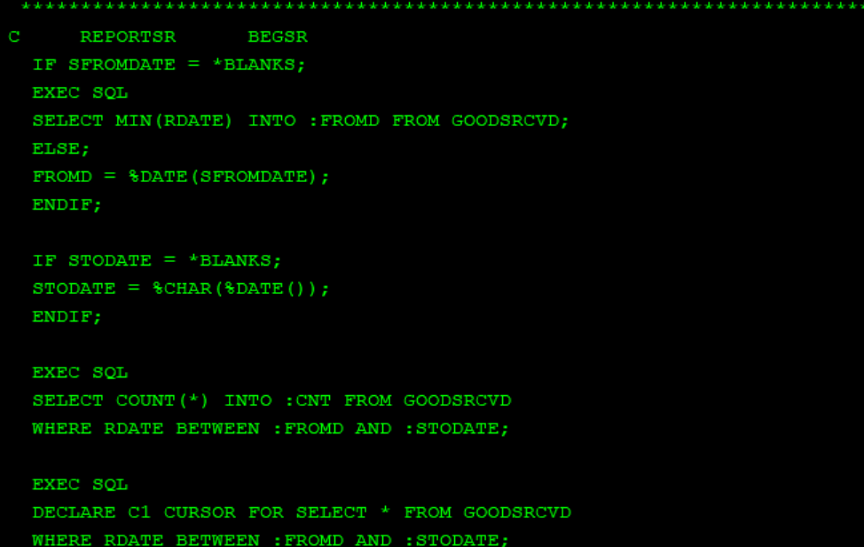

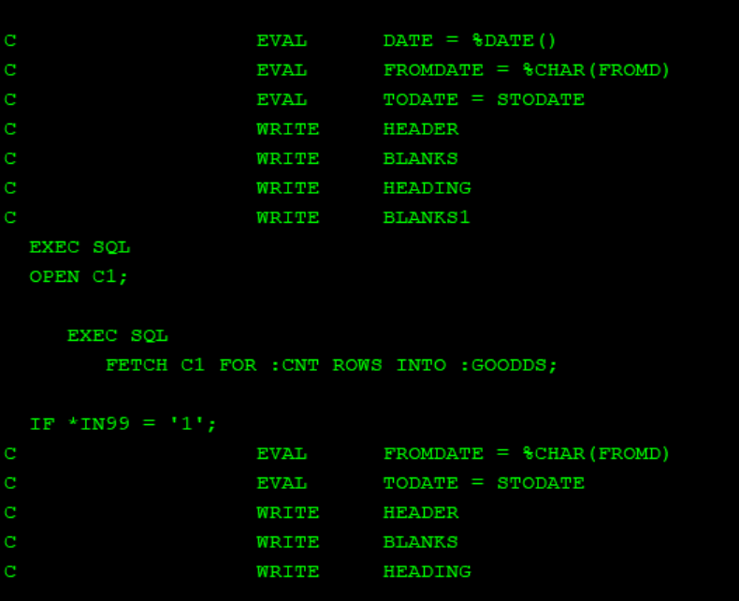

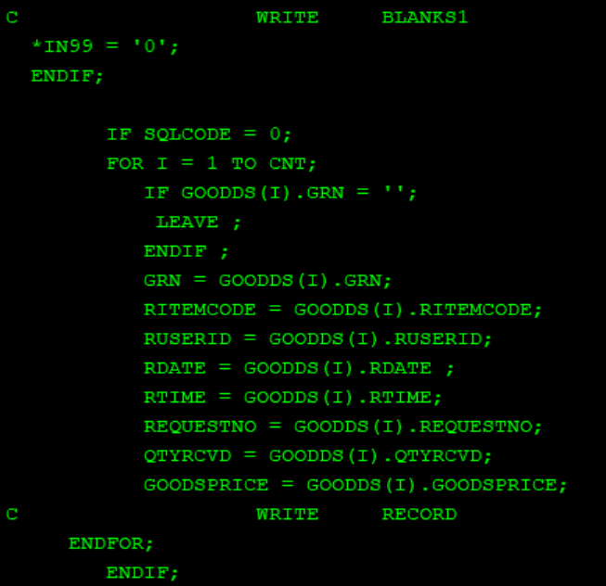

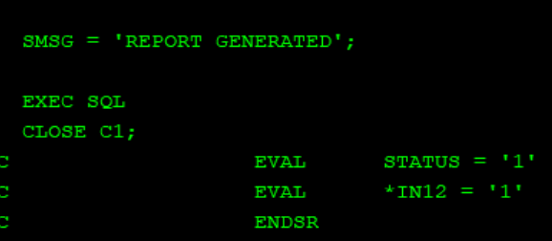

SHOWSPOOLF

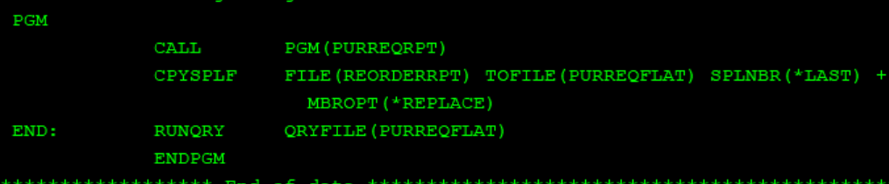

PURREQRPT

